Conversion Rate by Device & Customer Segment
This query helps you understand if "New" vs. "Returning" customers prefer buying on Mobile, Desktop, or Tablet, and where your leaks in the funnel might be.
QUERY-;
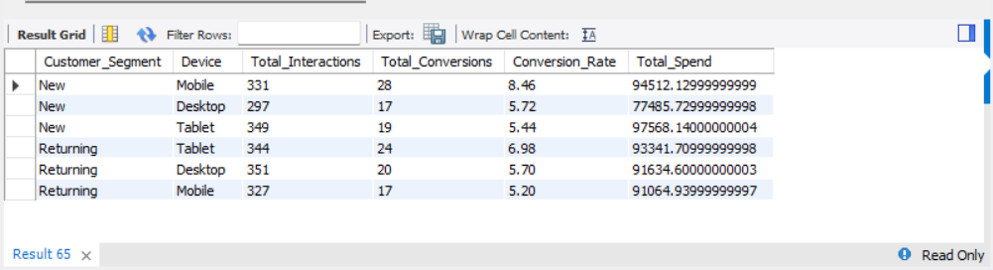
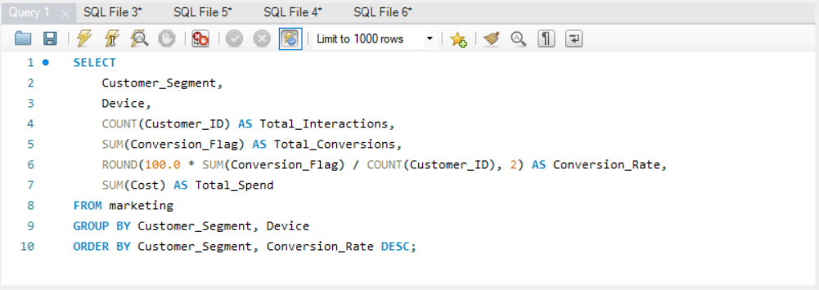

SOLUTION-;

